RAFFLE TICKETS
$10 each

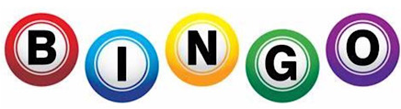
Saturday, March 21, 2026
RAFFLE
DRAWING AT 9 PM!

Arco Fire Hall, 101 South Railroad St
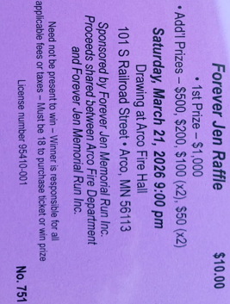
Social hour – 5:00pm
RAFFLE DRAWING AT 9 PM! 1st PRIZE - $1,000
Loaded Forever Fries – 5:30pm
Adults - $15, Kids 12 & under - $10
(Pulled Pork, BBQ, Onions, Jalapenos, Bacon Crumbles, Black Olives, Cheddar Cheese)
BINGO & Meat Raffle – 6:00pm
TICKETS AVAILABLE!
Cash Bar - Pull tabs – Cash Prizes

CASH, VENMO, PAYPAL or Donate at foreverjen.org

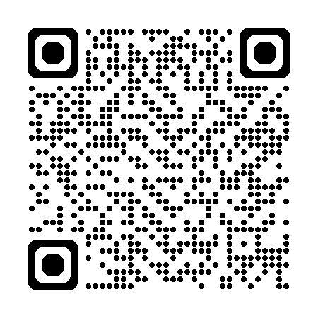
PROGRESSIVE BINGO - Last night!
Last game of the night! Jackpot starting at $50

bl

